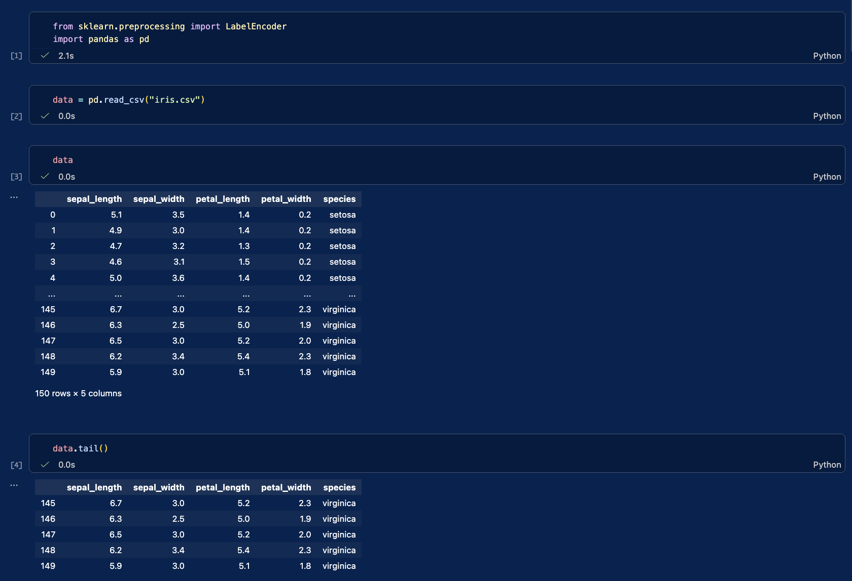
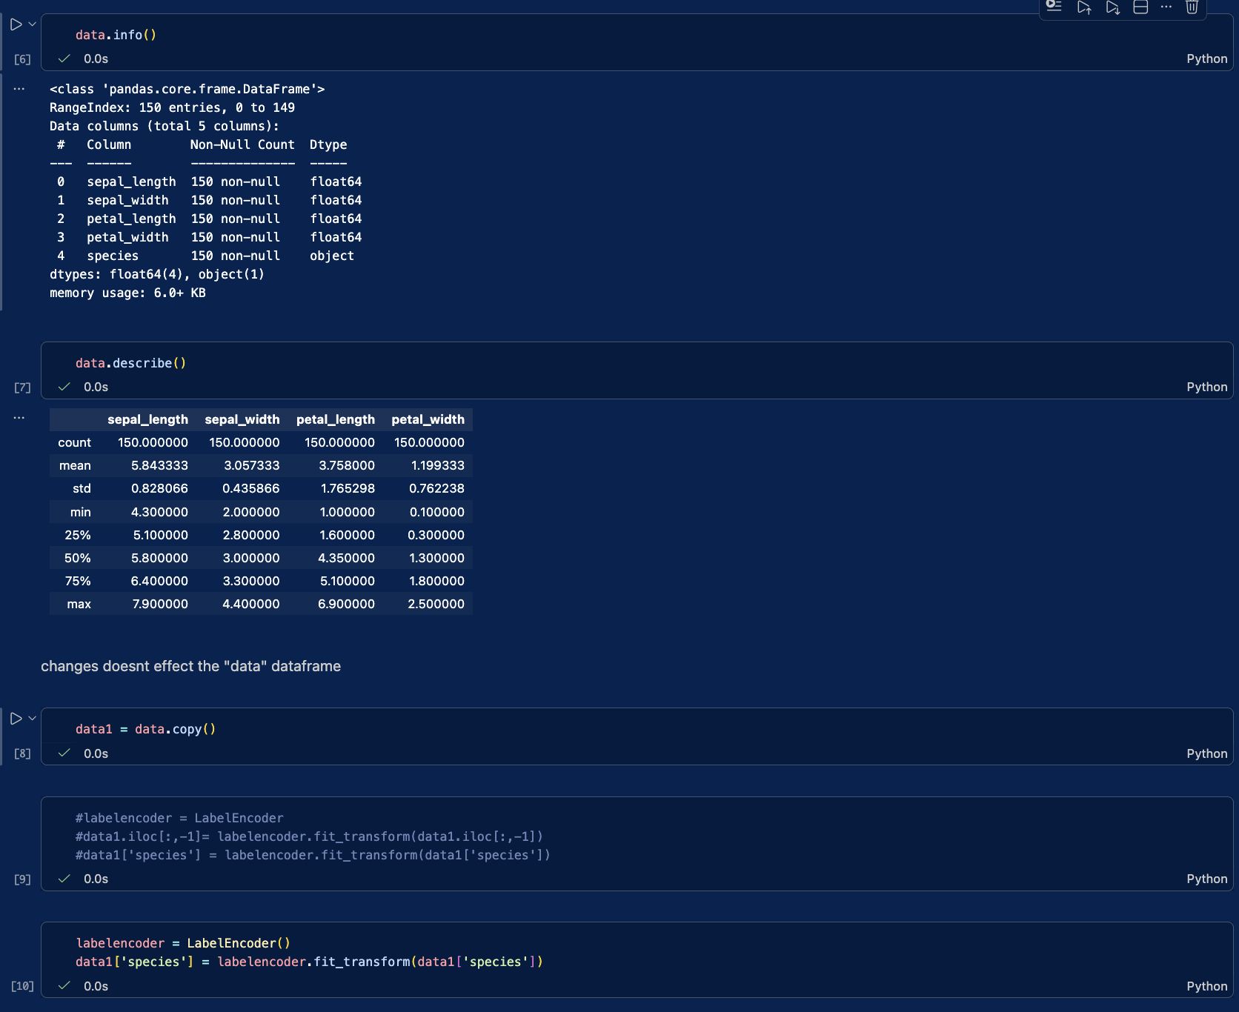
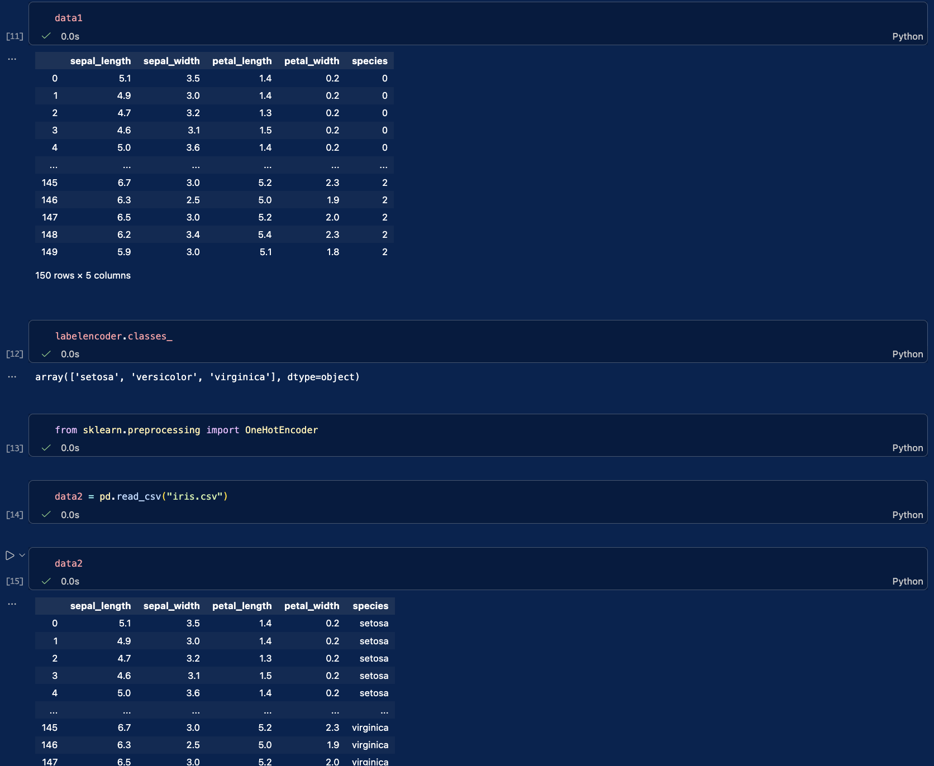
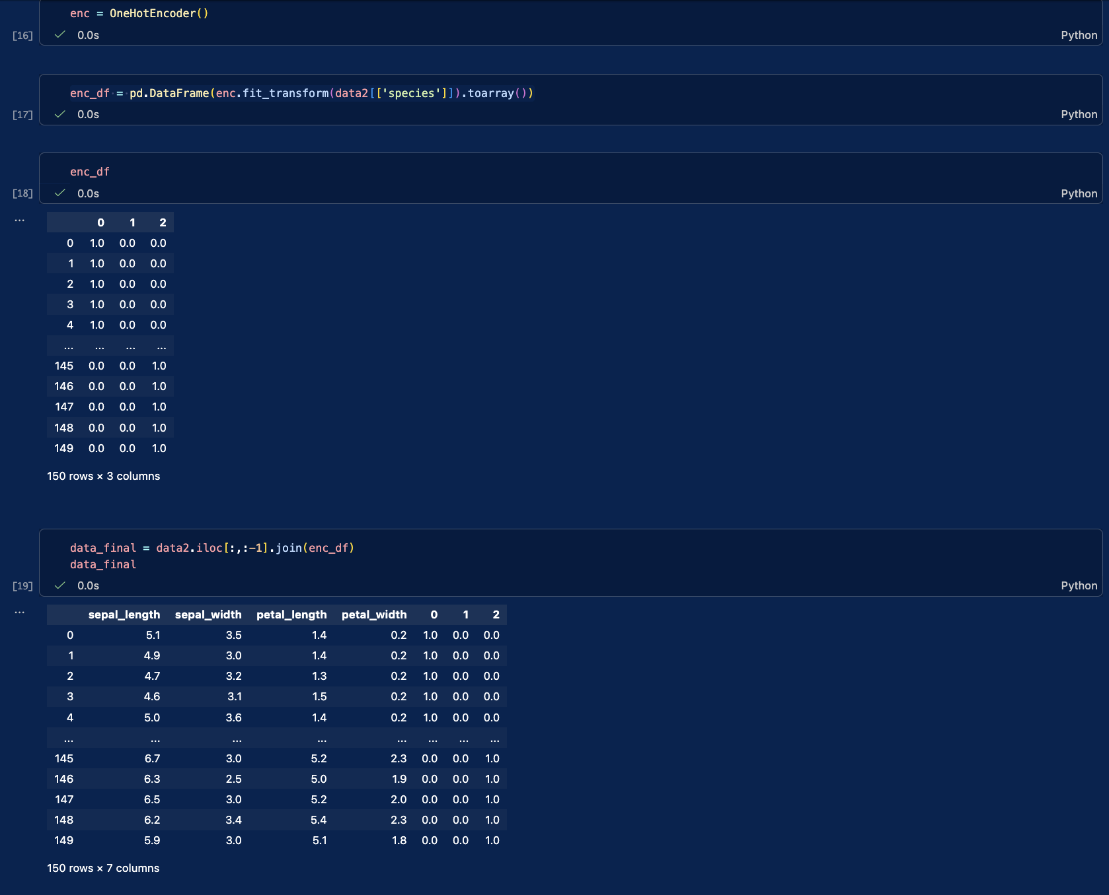
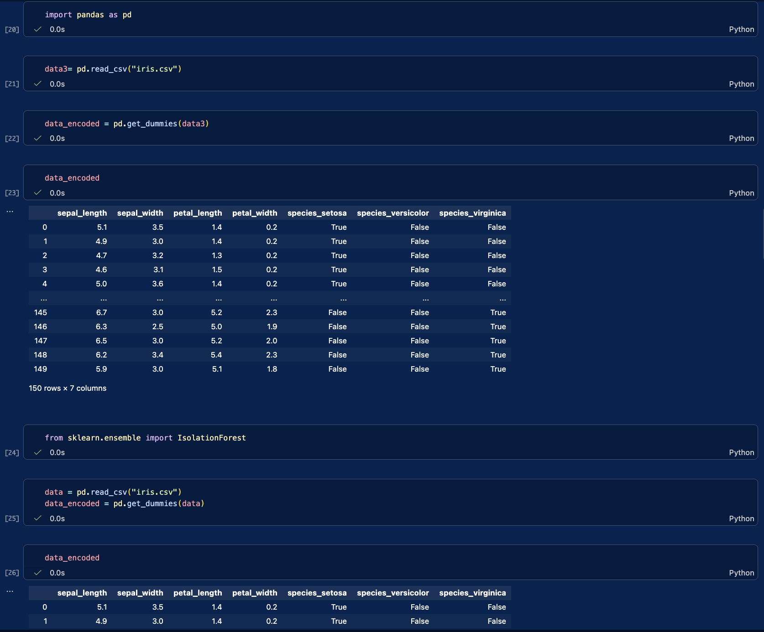
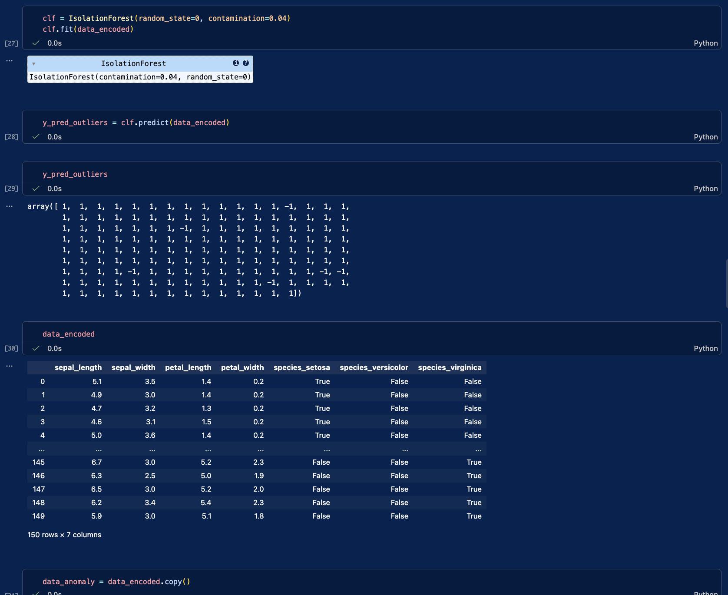
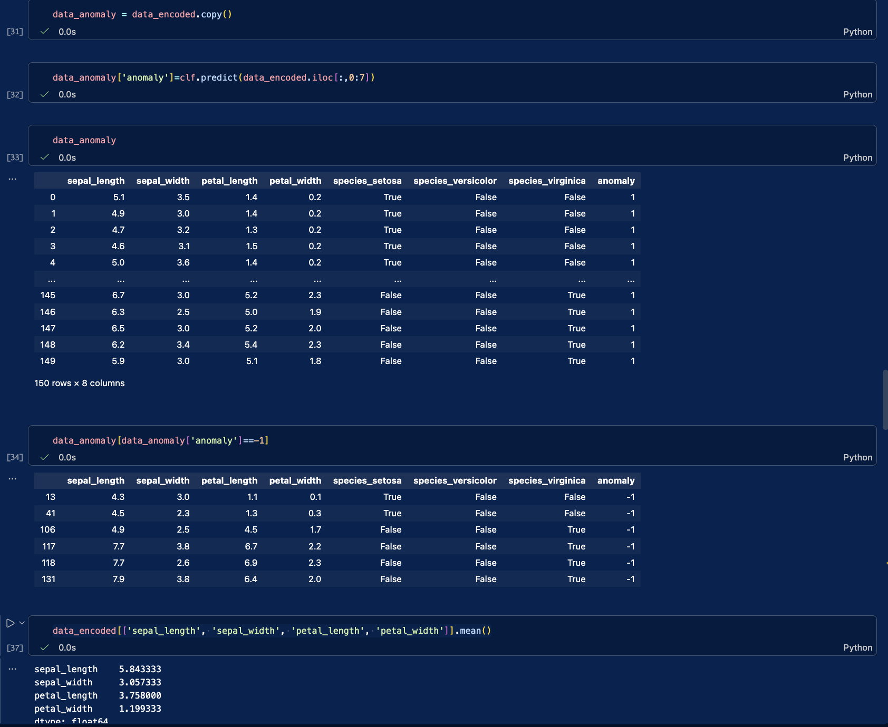
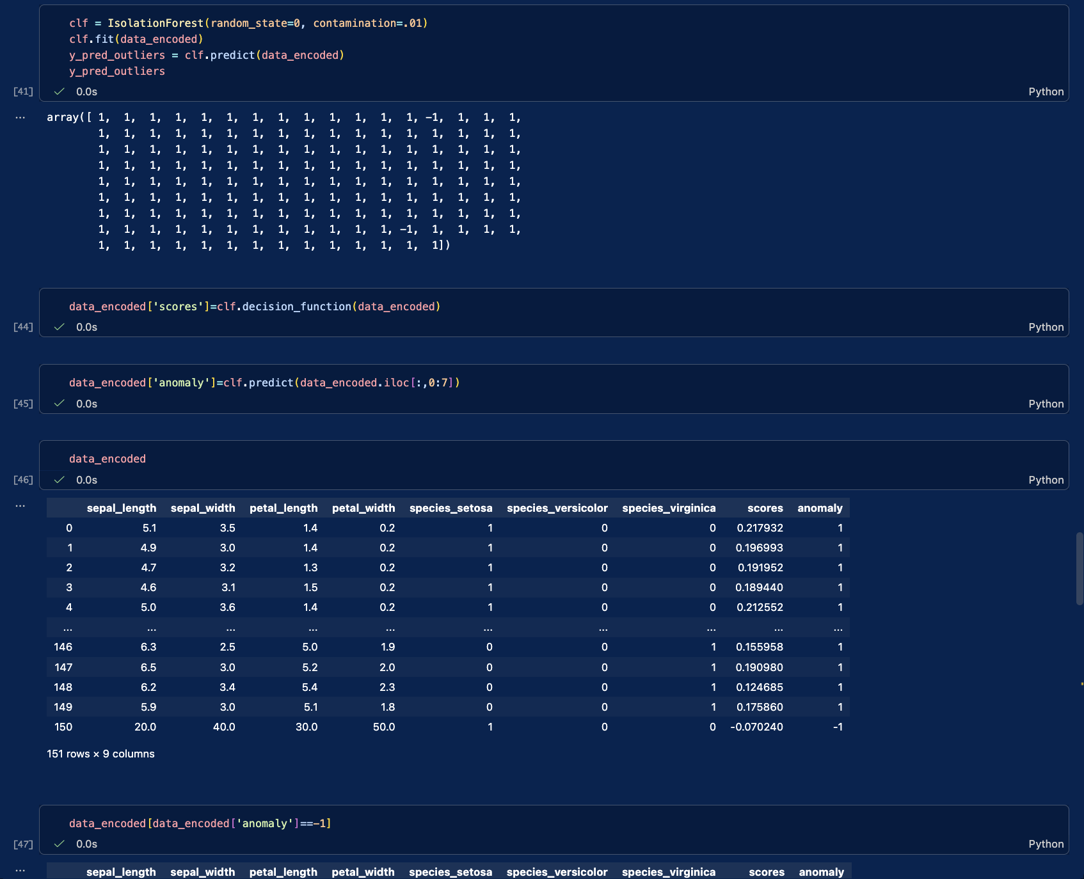
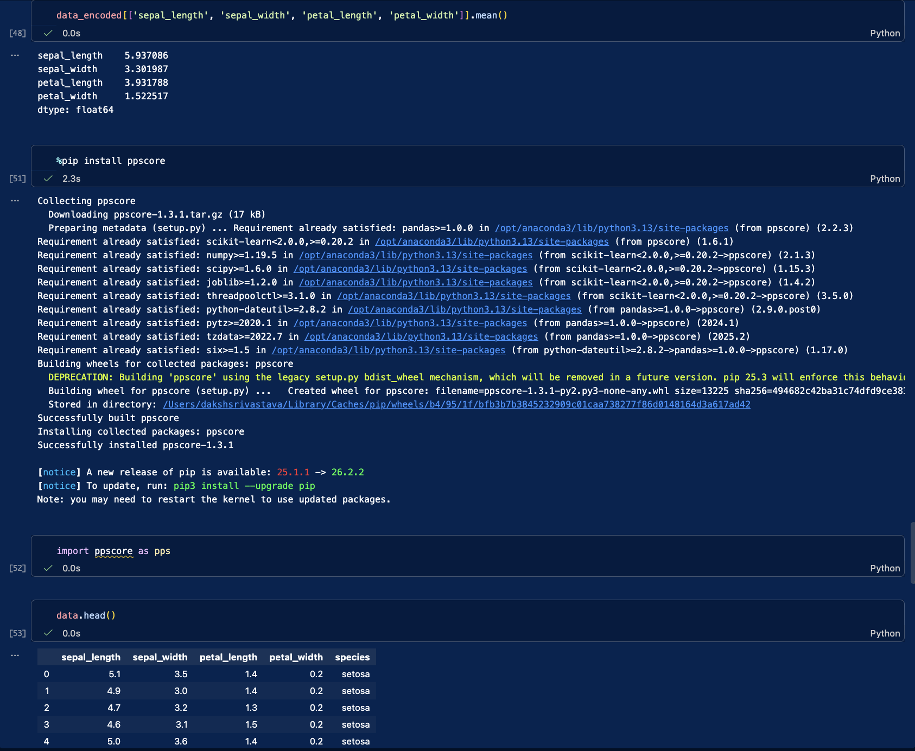
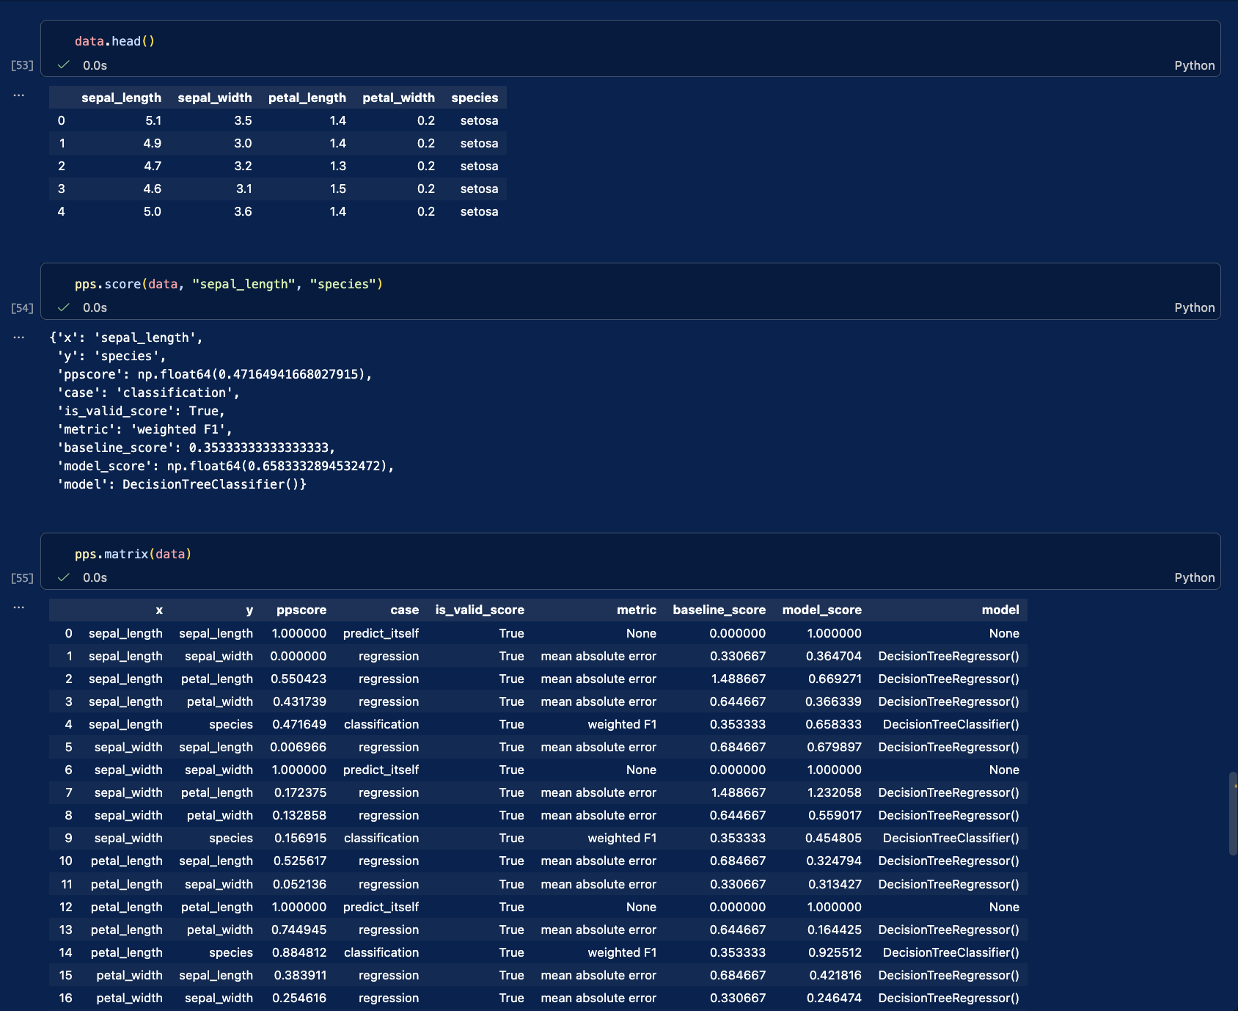

- imports pandas and the label encoder.
- loads the iris dataset from iris.csv.
- displays the full dataset.
- shows the last few rows.
- shows the last few rows again.
- displays column names, data types, and row counts.
- gives summary statistics for the numeric columns.
- notes that edits to a copy won’t change the original data.
- creates a copy of the dataset.
- shows commented-out examples of label encoding.
- converts species names into numeric labels.
- displays the dataset with encoded species.
- shows the species names and their label order.
- imports the one-hot encoder.
- loads a fresh copy of the iris dataset.
- displays the dataset.
- creates a one-hot encoder.
- converts each species into its own 0/1 column.
- displays the new species columns.
- joins the encoded species columns with the measurements.
- imports pandas.
- loads the dataset again.
- converts text columns into 0/1 columns using get_dummies.
- displays the encoded dataset.
- imports isolation forest for finding unusual rows.
- loads the data and encodes the species column.
- displays the encoded data.
- fits an isolation forest, setting the expected outlier rate to 4%.
- predicts which rows may be outliers.
- displays the predictions: -1 means outlier and 1 means normal.
- displays the encoded data again.
- copies the data to store anomaly results.
- adds an outlier prediction to each row.
- displays the data with the new anomaly labels.
- shows only the rows marked as outliers.
- calculates the average flower measurements.
- adds a sample row with unusually large measurements.
- fits the model again with a 1% outlier setting and predicts again.
- adds an anomaly score; lower scores suggest a row is more unusual.
- adds an outlier label to each row.
- displays the data with its scores and labels.
- shows only the rows marked as outliers.
- recalculates the average measurements, including the added sample row.
- installs ppscore for predictive power analysis.
- imports ppscore.
- displays the first few rows of the dataset.
- checks how well sepal length predicts species.
- calculates predictive power scores for pairs of columns.
- displays the score matrix again.
this notebook explores the iris dataset step by step. it first loads and checks the data, then shows a few ways to convert the flower species names into numbers so they can be used in machine learning. after that, it uses isolation forest to look for unusual flower measurements, including a sample row with very large values. finally, it uses predictive power score to check how well one column, such as sepal length, can help predict another, like species.

Name : Daksh Ranjan Srivastava
Roll no : 150096725087

